ASSIGNMENT 6.3

**DATASET:**

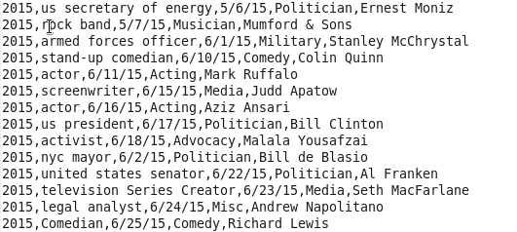

**DRIVER:**

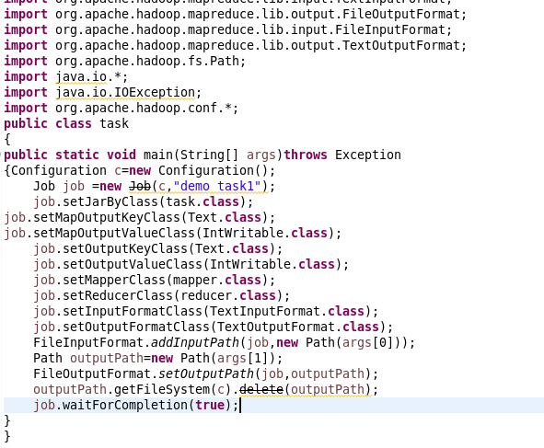

**REDUCER:**

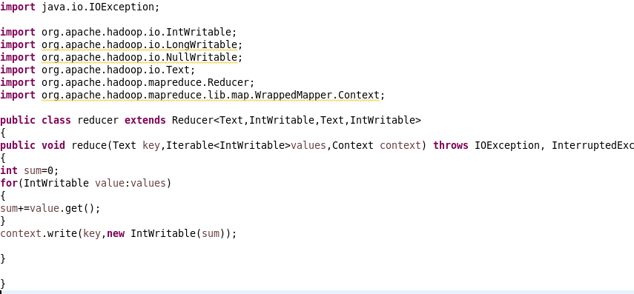

1. **Find the number of GoogleKnowledge occupation types in each group, who have been guests on the show**

**MAPPER:** 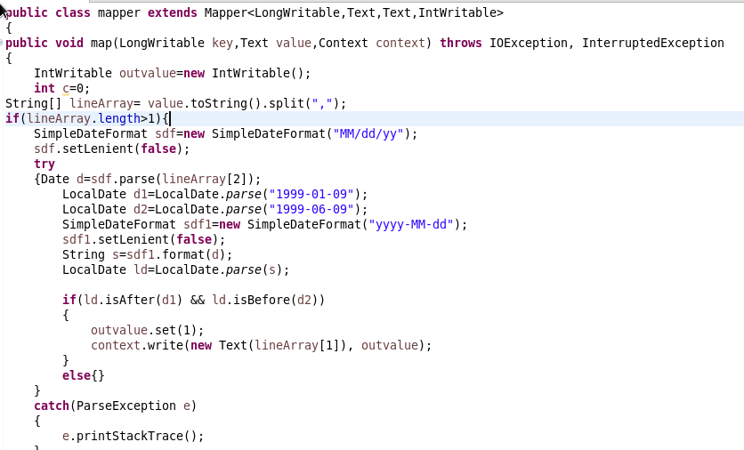

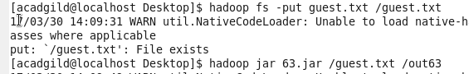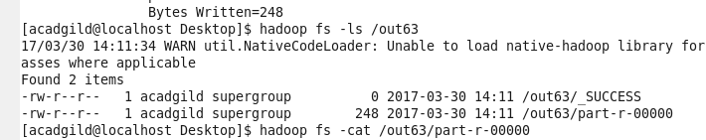

**OUTPUT:**

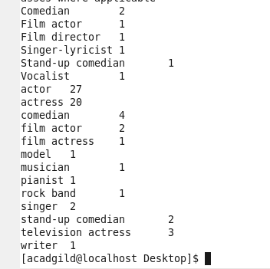

**2) Find out the number of people undertaken the trips from the places MIA and HOU**

**MAPPER:**

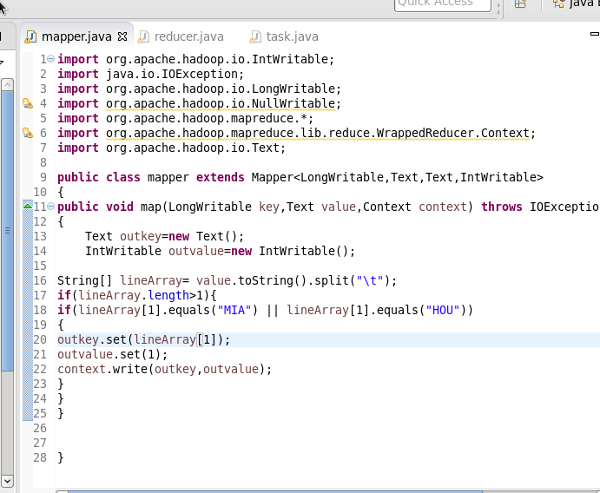

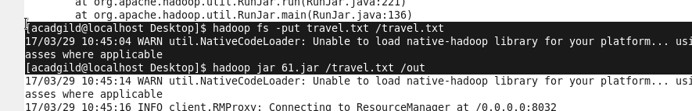

**OUTPUT:**

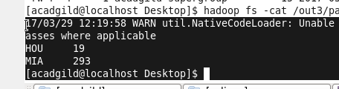

**3)Find out how many people has chosen airline mode of travel for the places LAS and LAX**

**MAPPER:**

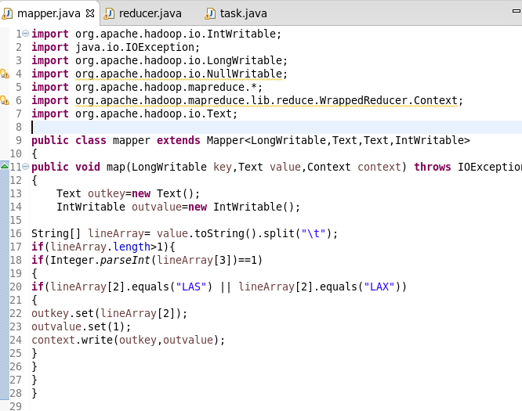



**OUTPUT:**